American University of Sharjah  College of Engineering  Dept of Computer Science & Engg  P. O. Box 26666  Sharjah, UAE |  | Lab Instructor: Salsabeel Shapsough  Office: ESB-1010  Phone: 971-6-5154948  e-mail: sshapsough@aus.edu  Semester: Fall 2024

Lab #10 – Latches and D-Flip Flops

Objectives
To construct basic latches using logic gates and demonstrate their operation.

Lab Equipment and Circuit Components
Equipment
- Breadboard
- Switches and LEDs
CIRCUIT COMPONENTS (Data sheets are available in Data Sheets folder)
IC type 7400, 7402, 7404, 7474

Introduction

Latches:

A latch is a type of bi-stable logic device or multi-vibrator. An active-High input S-R (SET-RESET) latch is formed with two cross-coupled NOR gates as shown in Fig (2.a); an active-LOW input S-R latch is formed with two cross-coupled NAND gates as shown in Fig (2.b). Logic symbols for both latches are illustrated in Fig (3).

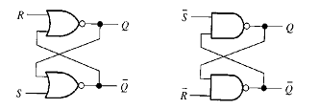 |  |  | 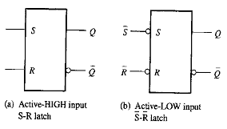
Fig (2.a). | Fig (2.b). |  | Fig (3.a). | Fig (3.b).

Notice that the output of each gate is connected to an input of the opposite gate. This produces the regenerative feedback, a characteristic of all latches and flip-flop.
The gated D latch differs from the S-R latch because it has only one input in addition to EN. This input is called D (data) input. Fig (4) contains a logic diagram and logic symbol of a D latch. When the D input is HIGH and the EN input is HIGH, the latch will set. When the D input is LOW, and EN is HIGH, the latch will reset. Stated in another way, the output Q follows the input D when EN is HIGH.

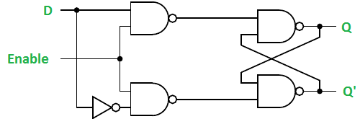
Fig (4)

D Flip-flops

The 7474 chip is a Dual Positive-Edge-Triggered D-Type Flip-Flops with Preset, Clear and Complementary Outputs. The two D flip-flops are independent. The information on the D input is accepted by the flip-flops on the positive going edge of the clock pulse. The data on the D input may be changed while the clock is LOW or HIGH without affecting the outputs as long as the data setup and hold times are not violated. A LOW logic level on the preset or clear inputs will set or reset the outputs regardless of the logic levels of the other inputs. Figure 3 shows the connection diagram and function table of the 7474 D flip-flop.

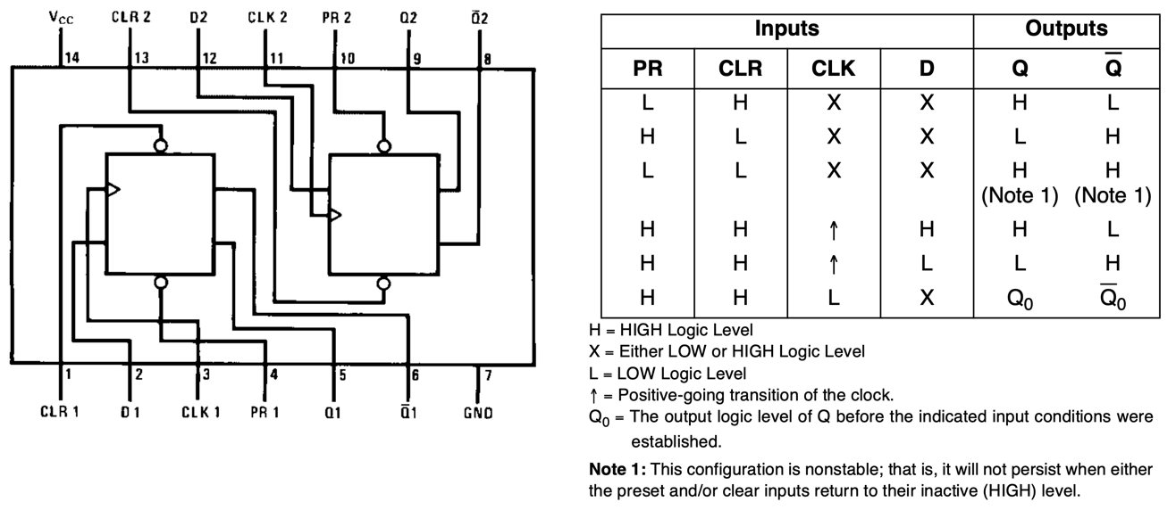
Figure 3. 7474 Connection Diagram and Function Table

Lab Assignments:

Exercise 1:
Connect the circuit of Fig(2.a) and verify its operation using discrete logic gates. Fill the following truth tables for both active-HIGH S-R latches.

R | S | Q | Q’
0 | 0
0 | 1
1 | 0
1 | 1

Exercise 2:
Connect the circuit of Fig(4) and verify its operation using discrete logic gates. Fill the following truth table below for the gated D-latch.

D | EN | Q | Q’
0 | 1
1 | 1
X | 0

Exercise 3:
Implement and verify the operation of the D flip-flop (7474) on the Breadboard. Fill in the following table:

Inputs |  |  |  | Outputs
$$\underline{PRE}$$ | $$\underline{CLR}$$ | $$\underline{CLK}$$ | $$D$$ | $$Q$$ | $$\underline{Q}$$
L | L | X | X
L | H | X | X
H | L | X | X
H | H | ↓ | L
H | H | ↓ | H
H | H | H | X

